**DAILY ONLINE ACTIVITIES SUMMARY**

|  |  |  |  |  |  |  |  |  |
| --- | --- | --- | --- | --- | --- | --- | --- | --- |
| **Date:** | 14-06-2020 | | | | | **Name:** | K S Prajwal | |
| **Sem & Sec** | IV A sec | | | | | **USN:** | 4AL18CS032 | |
| **Online Test Summary** | | | | | | | | |
| **Subject** | | N/A | | | | | | |
| **Max. Marks** | | N/A | | **Score** | | | N/A | |
| **Certification Course Summary** | | | | | | | | |
| **Course** | Face Recognition with Deep Learning using Python | | | | | | | |
| **Certificate Provider** | | | Udemy | | **Duration** | | | **3 hr** |
| **Coding Challenges** | | | | | | | | |
| **Problem Statement:**  1: program to remove a substring of a string.  2: finding the min number of steps  3: program to find the pair of vowel and consonant | | | | | | | | |
| **Status:** completed | | | | | | | | |
| **Uploaded the report in Github** | | | | | yes | | | |
| **If yes Repository name** | | | | | <https://github.com/alvas-education-foundation/KS_Prajwal> | | | |
| **Uploaded the report in slack** | | | | | yes | | | |

Online Test Details: (Attach the snapshot and briefly write the report for the same)

Certification Course Details: (Attach the snapshot and briefly write the report for the same)

Coding Challenges Details: (Attach the snapshot and briefly write the report for the same)

**Online Test Details:N/A**

Snapshot of certification course: 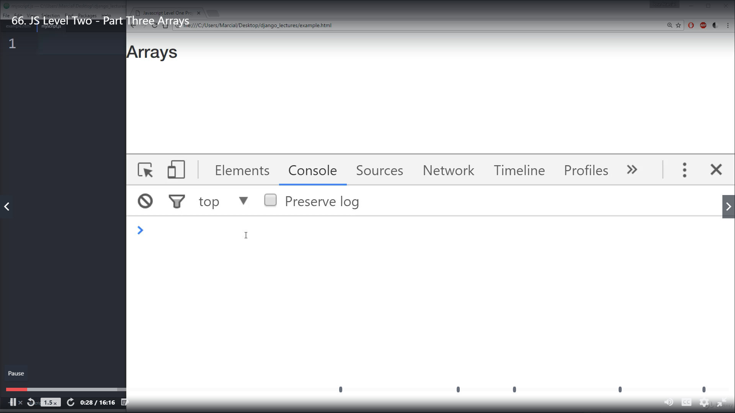

This section was about the array implementation in javascript and function

**Online coding:**

Problem 1: (using C language) program to remove a substring of a string.

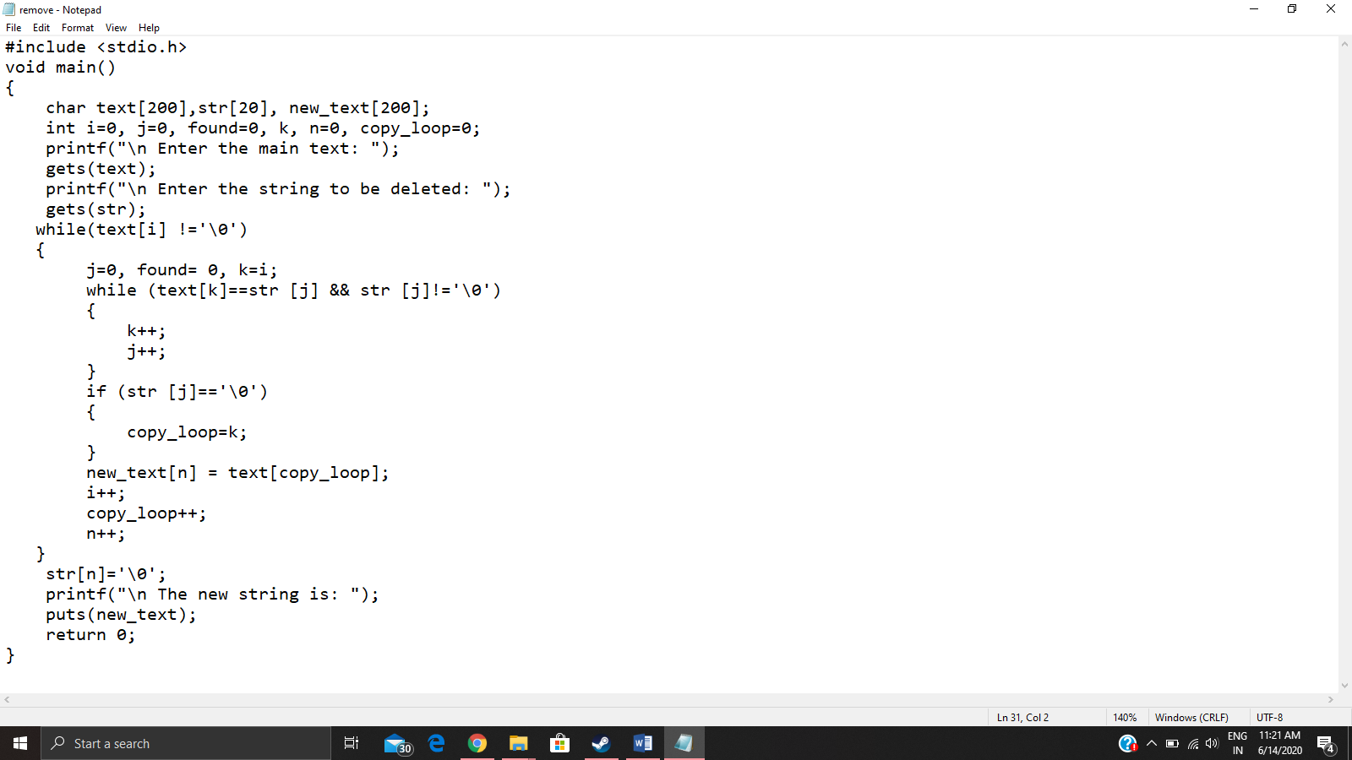

Problem 2: (using python) There are three integers k,m,n. You have to convert the number k to m by performing the given operations:

* Multiply k by n
* Decrease k by 2.
* Decrease k by 1.

You have to perform the above operations to convert the integer from k to m and find the minimum steps.

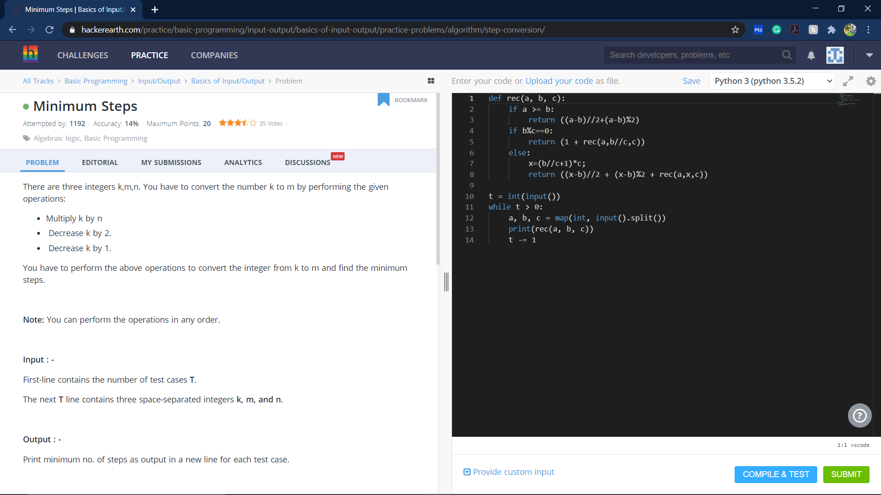

Program 3: Max has a string S with length N. He needs to find the number of indices i (1≤i≤N−11≤i≤N−1) such that the i-th character of this string is a consonant and the i+1th character is a vowel. However, she is busy, so she asks for your help.

